# Week 13 Lab 1 Practical

# Duties of a DBA - Backup and Restore

**Completing this worksheet will help prepare you for the next mini assessment. This is a checkpoint, you may work in pairs.**

1. **What are some common tasks a DBA can be expected to complete? For each also list how often they should occur**

Everyday:

Check database and transaction log backups and agent errors

Check all databases make sure all are up

Weekly:

Check for full system backup status

Verify the database is being backed up

Test restores of the database backups on test server

Monthly:

Check windows updates and System performance

Verify data access speed is running at normal level

Check the capacity of database in order to expending

Quarterly:

Perform full test of disaster recovery plan

Check the system running performance such as cup, memory status

1. **How would you automate your production backups?**

Use SSMS management tools to create a jobs schedule

1. **How would you check your backups to validate that they were successfully created?**
   1. Use DBCC CHECKDB to check it
   2. Use RESTORE VERIFYONLY to check it
   3. Copy back up file to other test SQL SERVER to restore and test it.
2. **List the three backup models in SQL Server and the associated pros and cons.**

|  |  |  |
| --- | --- | --- |
| **Model** | **Pros** | **Cons** |
| Full | Individual files, small, easy way | Does not support time line restore |
| Transaction Log | High availability, backup by time range | It’s not an entire database backups, the transaction log chain might be too long |
| Differential | Quick restore , small, high efficient | Take long time to restore, need backup frequent |

1. **List the two ways these backup models can be set (include any syntax)**
2. Use SSMS Management
   * Right click Database which is we want to back up
   * Choose Task -> Back Up
   * From back up type option, we can choose the three models.
3. Use TSQL

Full

USE Pubs

GO

BACKUP DATABASE [Pubs] TO DISK = ‘/var/opt/mssql/data/test.bak’ WITH COMPRESSION, INIT, STATS = 5;

GO

Transaction Log

Change the recover mode to FULL RECOVER mode  
USE Pubs

GO

ALTER DATABASE [Pubs] SET RECOVERY FULL WITH NO_WAIT

GO

Starting backup  
USE Pubs

GO

BACKUP LOG [Pubs] TO DISK = N'/var/opt/mssql/data/testTL_1.trn' WITH COMPRESSION, STATS = 1;

BACKUP LOG [Pubs] TO DISK = N'/var/opt/mssql/data/testTL_2.trn' WITH COMPRESSION, STATS = 1;

BACKUP LOG [Pubs] TO DISK = N'/var/opt/mssql/data/testTL_3.trn' WITH COMPRESSION, STATS = 1;

GO  
  
Using the code below to view the log chain relationship  
USE Pubs

GO

RESTORE HEADERONLY FROM DISK = N'/var/opt/mssql/data/testTL_1.trn';

RESTORE HEADERONLY FROM DISK = N'/var/opt/mssql/data/testTL_2.trn';

RESTORE HEADERONLY FROM DISK = N'/var/opt/mssql/data/testTL_3.trn';

GO

Differential

USE Pubs

GO

BACKUP DATABASE [Pubs] TO DISK = '/var/opt/mssql/data/differential_bak.bak' WITH DIFFERENTIAL

GO

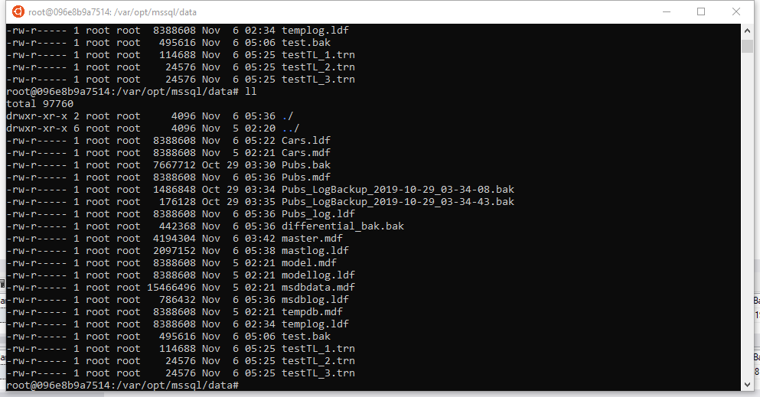

After all three kinds of backup the SQLSERVER will have the backup file above.

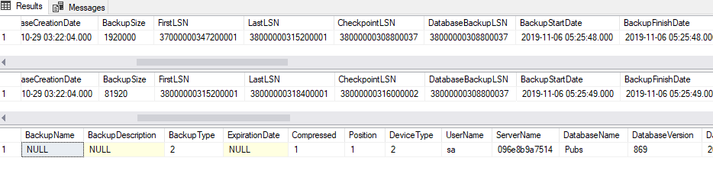

Transaction Log relationship like the picture above.

**Let have a quick run through. Files on the I: drive and in Gitlab.**

**Install the Pubs database on your containerised MSSQL Server (installpubs.sql).**

**Take a full backup of your Pubs database (make sure you have closed any query windows).**

**Insert the Pubs data.**

**Take a differential backup.**

**Insert a new author <YourName> (or update an existing author).**

**Take a differential backup.**

**Restore the full backup only (explore the Options and the Timeline)**

**Verify there is no data.**

**Restore the full backup + differential + transactions logs.**

**Confirm your data is in its most recent state.**

**DBCC CHECKDB for allocation or consistency errors.**

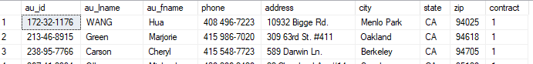

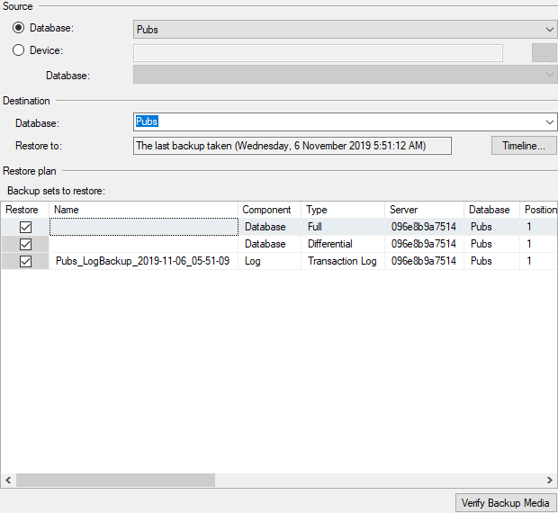

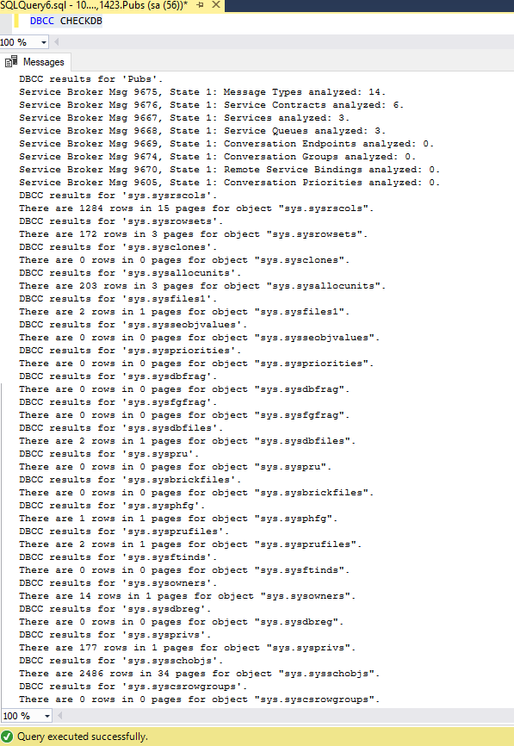

USE [master]

BACKUP LOG [Pubs] TO DISK = N'/var/opt/mssql/data/Pubs_LogBackup_2019-11-06_05-51-44.bak' WITH NOFORMAT, NOINIT, NAME = N'Pubs_LogBackup_2019-11-06_05-51-44', NOSKIP, NOREWIND, NOUNLOAD, NORECOVERY , STATS = 5

RESTORE DATABASE [Pubs] FROM DISK = N'/var/opt/mssql/data/test.bak' WITH FILE = 1, MOVE N'Pubs' TO N'/var/opt/mssql/data/Pubs.mdf', MOVE N'Pubs_log' TO N'/var/opt/mssql/data/Pubs_log.ldf', NORECOVERY, NOUNLOAD, STATS = 5

RESTORE DATABASE [Pubs] FROM DISK = N'/var/opt/mssql/data/differential_bak.bak' WITH FILE = 1, NORECOVERY, NOUNLOAD, STATS = 5

RESTORE LOG [Pubs] FROM DISK = N'/var/opt/mssql/data/Pubs_LogBackup_2019-11-06_05-51-09.bak' WITH FILE = 1, NOUNLOAD, STATS = 5

GO